Toronto Day of Action to Oppose the Criminalization of HIV

On February 8, the Supreme Court of Canada will hear two landmark cases about HIV, sex and the criminal law.

Stand for justice! Oppose the criminalization of HIV.
Make your voice heard.
Join the National Day of Action.

Where: Church of the Holy Trinity, 483
Bay Street, Toronto
When: Monday, 6 February at 5:30 pm
What: Calls to Action, March to Old City
Hall & Street Theatre

It is time to stop persecuting people living with HIV who have safe and consensual sex. The criminal law should only be used where a person puts another person at a
real risk of harm.
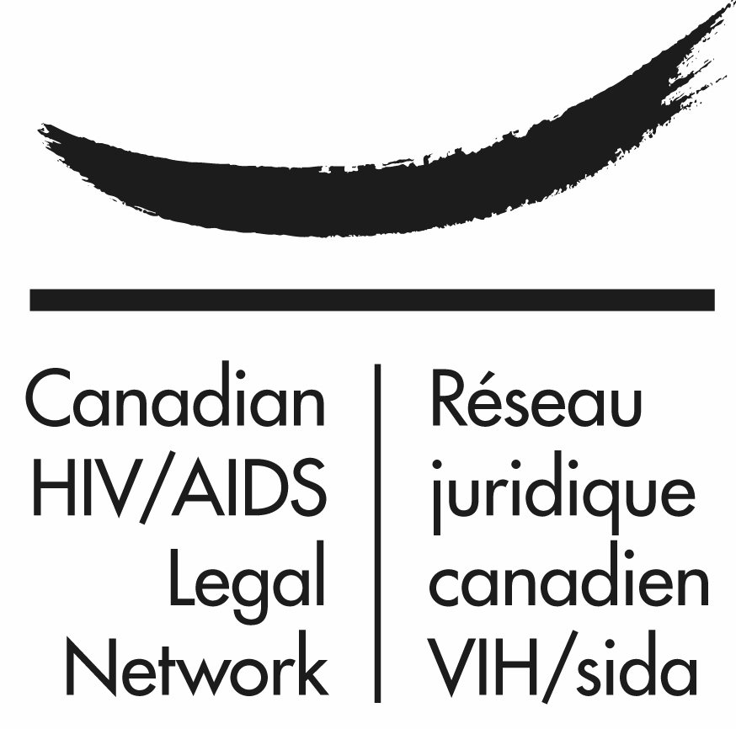


Fight silence, ignorance & prejudice. Learn about HIV and other sexually transmitted infections. Let’s all take control of our health.



